**Assignment 1**

* What is JDK? JRE? JVM?

1. JRE: an installation package includes JVM, libraries (integration, other base, Lang and util base), deployment technologies, user interface toolkits.
2. JDK: a development environment. JRE + development tools
3. JVM: a runtime environment that java bytecode can execute, run program in other language and compile to java byte code

* What is java compiler?

1. a program that takes the text file work of a developer and compiles it into a platform-independent Java file

* Why is java platform independent?

1. The Java programming language and all APIs are compiled into bytecodes, Bytecodes are effectively platform-independent.
2. it uses a virtual machine which takes care of the differences between the bytecodes for the different platforms

* What is IDE? Why is it important for developers?

1. an integrated development environment for programming in Java;
2. provide a code editor, a compiler or interpreter and a debugger that the developer accesses through a unified graphical user interface

* Is java case sensitive?

Yes

* What do the following key words do?  
  static: belongs to the class than an instance of the class

variable

- refer to the common property of all objects

- gets memory only once in the class area at the time of class loading

method:

- can be invoked without the need for creating an instance of a class

- can access static data member and can change the value of it

- Static nested classes do not have access to other members of the enclosing class

block:

- initialize the static data member

- executed before the main method at the time of classloading

final:

variable:

* you cannot change the value of final variable (if it is passed by reference, then reference)
* blank final variable can only be initialized in constructor
* A static final variable that is not initialized at the time of declaration is known as static blank final variable. It can be initialized only in static block.

method:

* cannot override

class:

* cannot extend it, but can be inherited

public:

* an access modifier used for classes, attributes, methods and constructors, making them accessible by any other class.

private:

* an access modifier used for attributes, methods and constructors, making them only accessible within the declared class.

Void

* denotes that a method does not have a return type.

Null

* not a keyword, a reserved word for literal values

package

* specify a directory structure to which the current source file must belong

class:

* declare a new Java class, which is a collection of related variables and/or methods

new

* create an instance of the class, it instantiates a class by allocating memory for a new object and returning a reference to that memory

* What is primitive type and reference type?
* primitive: stored directly on the stack, int, byte, short, long, float, double, boolean and char

* reference: It contains the address (or reference) of dynamically created objects. a subclass of type java.lang.Object.

* Is parameter passed by value or reference?

passed-by-value

* What is the output: System.out.println(1 > 0 : “A”:”B”);

wrong command, ":" after 0 should be "?"

* How to define constants in java?

static / final modifier

* What is String? Is it primitive type?

Objects that are backed internally by a char array.

* How to check if a String is representing a number?

use parseInt() / valueOf / parseDouble / parseFloat()/ parseLong()

* Write a program to implement the following activity diagram:

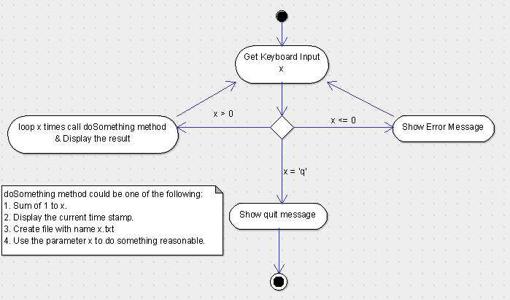

* Write a program to merge two array of int.
* Write a program to find the second largest number inside an array of int.